BOARD MEMBER – AGED RIGHTS ADVOCACY SERVICE (SA) INC

POSITION DESCRIPTION

ARAS
The Aged Rights Advocacy Service (ARAS) is a statewide, not-for-profit, independent, community based organisation that has provided advocacy services for older people across South Australia since 1990. Older people who use community or residential aged care services, people who live in retirement villages, and older people who are experiencing or who are at risk of abuse from family or friends, can request an ARAS advocate to assist them to address their concerns. ARAS has an Aboriginal Advocacy program to support and advocate for older Aboriginal people.

ARAS has an experienced Board of non-executive Directors and highly trained staff who provide information and education about aged care and broader human rights and representation to resolve issues and ensure the voice of the older person is heard.

ARAS is a member of the national Older Person Advocacy Network Ltd (OPAN) and a member of Elder Abuse Action Australia Ltd.

ARAS’s Vision is a community in which all older people are valued and respected.

ARAS’s Purpose Statement is to encourage and support older people and community to uphold the rights of older people through information, education, advocacy and personal empowerment

ARAS’s Mission is to increase the person’s control over goods, services, quality of life, and to develop a sense of empowerment and of being valued as individuals and citizens of Australia, through an advocacy process.

ARAS’s Values are Integrity, Inclusiveness, Justice and Respect.

ARAS Objects are:
- Provide a service to represent and promote the interests of the following older people (or their representatives) in South Australia:
  - Residents and potential residents of Commonwealth-subsidised residential care facilities, their carers and representatives
  - Frail older people living in the community who receive or are eligible for Community Care packages, and their carers
  - Older people who are at risk of or experiencing abuse, and
  - Other groups of older people who are in need of services of a similar nature.
- Provide information and advice to the above groups of older people (or their representatives) about their rights and responsibilities.
- Support the above groups of older people or their representatives through advocacy processes.
- Promote community awareness of the rights of older people.
- Do all such other things as may be incidental to the attainment of such objectives.

Functions of the Board member
Subject to the Rules, each Board Member will hold office until the conclusion of the third annual General meeting after the Board Member was last elected, but is eligible for re-election.

The Board member is responsible for the sound, ethical and legal governance and financial management of ARAS through policy and strategy development. Board members provide guidance and direction based on the Strategic Plan and ensure ARAS has adequate resources to advance its mission.

Expectations of the Board member
In addition to the above functions and responsibilities, the Board member will participate as an active member of the Board and at all times act in the best interest of ARAS and its stakeholders. This will include but not be limited to:
- Attending Board meetings fully prepared
- Ensuring the organisation is compliant in relation to all relevant legislation and accounting standards
- Complying with the legal and fiduciary responsibilities of a director
- Promoting the organisation within the community
- Participating in at least one Board Committee.

Meetings of the Board
The Board currently meets bi-monthly. There is a Finance, Audit & Risk Management Committee which meets monthly, Governance and Performance Committee that meets bi-monthly /or as required and a Reconciliation Action Plan Committee which meets as required.

The AGM is held in conjunction with the November/December meeting.

Support and assistance
The positions of Directors, including the Chair, are honorary. Travel, accommodation and out-of-pocket expenses for meetings may be reimbursed.

Assistance in carrying out the duties of the Board will be provided by the Chief Executive, and other staff as may be appropriate.

Key responsibilities
In carrying out the Functions the Board member will:
- Be able to communicate the organisation’s vision for the future
- Contribute meaningfully to Board deliberations and to sound decision-making
- Contribute to effective Board processes and relationships
- Identify conflict of interest and advise the Chair of any such interest
- Maintain confidentiality
- Foster a positive future-focused Board culture, and
- Contribute to meeting the strategic objectives of ARAS.

Personal criteria for appointment
The Board member will possess:
- demonstrated leadership skills, including a high degree of integrity, capacity to inspire trust, to resolve conflict and to work with other Board members
- experience as a Board Director
- demonstrated experience and sound knowledge of the sector and/or issues affecting older people
- excellent knowledge of governance matters, relevant to a not-for- profit organisation
- AICD qualifications will be viewed favourably but are not essential, depending on experience
- high level communication and interpersonal skills
- strategic thinking skills and experience
- ability to deal with complex information, often with short turn-around times
- empathy with the culture and objectives of ARAS
- ability to develop and maintain positive professional relationships with Board members and other members of OPAN and other key stakeholders
- the ability to develop and maintain a sound professional relationship with the Chief Executive and ARAS staff.

Status: | Approved | Control: | Board
Approved by: | ARAS Board | Version: | V-2
Originally issued: | V-1 June 2020 | Last reviewed: | June 2020
Effective date: | June 2020 | Next review date: | August 2023

Signed by Chair 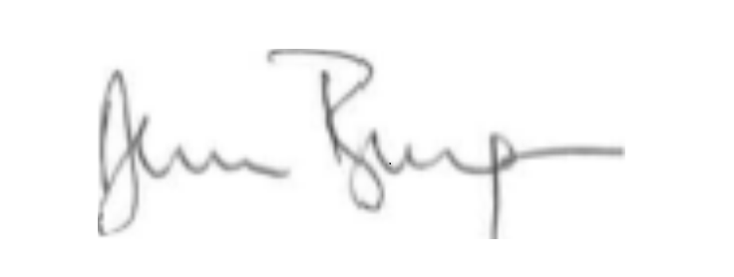

Date 30/8/21

