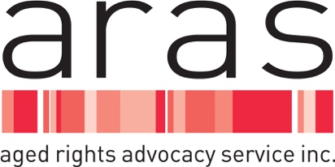

MEDIA RELEASE

Thursday 27 April 2023

ARAS CHAIRPERSON ANNE BURGESS APPOINTED AS NEW CHAIR OF AGED CARE COUNCIL OF ELDERS

The Aged Rights Advocacy Service (ARAS) welcomes the appointment of their Chairperson, Anne Burgess AM, as the new Chair of the Aged Care Council of Elders.

Ms Burgess takes over the role of Council of Elders Chair from Ian Yates AM, who commenced his role as Interim Inspector-General of Aged Care in February.

“Anne gives generously of her time, skill, knowledge and expertise, contributing to much needed aged care reforms,” ARAS Chief Executive Carolanne Barkla said.

Ms Burgess’s distinguished career includes roles as Director of the Office for Women, and Acting Commissioner at the Equal Opportunity Commission in South Australia.

Chairperson of the Aged Rights Advocacy Service since 2017, and an OPAN Board Director, her knowledge of the aged care, health, mental health and equal opportunity sectors is extensive.
Ms Burgess is highly respected in South Australia for her work as a member of the governing body of the Northern Adelaide Local Health Network, and for her experience in the not-for-profit sector, including her current positions as Deputy President of COTA SA and Chair of their Policy Council.

“The Aged Care Council of Elders was a key recommendation of the Royal Commission into Aged Care Quality and Safety and is an important advisory body on aged care reforms. I know that Anne’s collaborative, solution focused approach will lead to better aged care outcomes for older people and congratulate her on behalf of Aged Rights Advocacy Service.” Ms Barkla said.

MEDIA CONTACT
Carolanne Barkla
Chief Executive
0439 206 184

