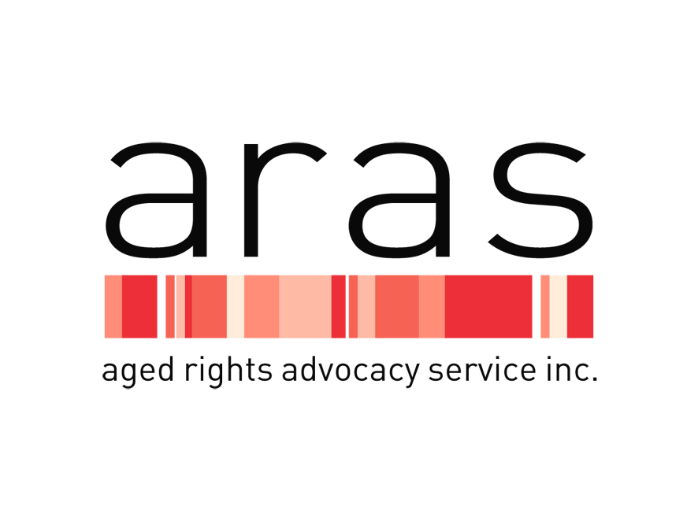

THE AGED RIGHTS ADVOCACY SERVICE INC. (ARAS)

POSITION DESCRIPTION

Applicants are requested to respond to the person specification in their application.
Please send written applications to Carolanne Barkla, Chief Executive ARAS, 16 Hutt St Adelaide 5000. Phone Inquiries to be directed to Louise Herft: 08 8232 5377.

ARAS has a website at www.sa.agedrights.asn.au

Role Title Human Resources Manager

Employment Status Part Time 0.6FTE

Location Adelaide

Classification Level Non Award Salary Range $65,000 - $75,000
Pro Rata – 9 month contract until June 2018.

Purpose of Role

The Human Resources Manager role is a newly created role as ARAS undergoes change and innovation ensuring older people are sufficiently informed to empower them to make their own choices and have their rights and interests respected.

The Human Resources Manager is responsible for the recruitment, selection, induction, performance management and exit of all ARAS staff, as well as management of all Human Resources functions for ARAS.

In this newly created role in ARAS the Human Resource Manager reports to and works closely with the Chief Executive Officer and maintains a collaborative and productive working relationship with all other staff within ARAS.

The Human Resource Manager is responsible for ensuring that all management of people and culture are consistent with the purpose, vision, and values of ARAS and comply with relevant legislation, quality standards and contemporary practice. ARAS aspires to reflective practice in all aspects of work, continuous quality improvement and the highest possible standards of service provision.

Human Resources

- Manages all aspects of ARAS Human Resources and Recruitment management in consultation with the Chief Executive;
- Manages and contributes to the development, implementation and monitoring of policies and procedures based on relevant legislation, enterprise bargaining, ARAS contractual obligations, ARAS service standards and contemporary human resource management practices;
- Manages Work, Health & Safety for ARAS;
- Manages all recruitment, selection, induction, performance management and exit of ARAS staff/contractors;
- Manages all aspects of employee related matters including but not limited to:
  - Employee records, position description reviews, performance appraisals, performance management and termination;
  - Update and maintain employee records including but not limited to police certificates, insurance, driver’s license, contracts, emergency contacts.
  - Manages staff leave, TOIL and employment conditions;
  - Manages, implements, monitors and ensures compliance with relevant legislative, Modern Awards changes, Human Resource procedures, delegations and related matters;
  - Manages Enterprise Bargaining processes;
- Manage ARAS quality review and continuous improvement systems;
- Any other relevant matters.

Teamwork and Communication

- Attend and actively participate in team meetings and project work.
- Demonstrate the ability to work positively and communicate effectively within a team environment as well as autonomously to achieve service delivery excellence.
- Maintain and initiate regular and professional communication with work colleagues and management.
- Develop and maintain cooperative and harmonious relationships and work in collaboration with others to prevent and/or resolve difficulties.

Continuous Quality Improvement

- Ensure that all statutory requirements are being met or exceeded including but not limited to funding agreements, Commonwealth and State legislation and related regulations and guidelines.
• Promote and support reflective practice in all ARAS staff, and demonstrate commitment to continuous quality improvement.
- Identify opportunities and options to promote and support high quality service provision and the best outcomes for clients, their families and staff.
- Participate and contribute in Workplace, Health and Safety activities to ensure a safe work environment for clients, staff, visitors and the community.
- Identify continuous improvements for all policies and procedures that support the inclusion and participation of clients.

Administration and Documentation

  - High level knowledge and usage of Microsoft Office and database programs.
  - Plan and manage time effectively to complete tasks and meet deadlines.
  - Complete written communications with staff and external services as required.
  - Implement and manage an employee records system.

Personal and Professional Development

  - Continue to develop professionally and personally to meet the changing needs of the position and the organisation.
  - Participate in the organisation’s performance management process.
  - Attend training as identified through the performance management process, or as identified by management.
  - Maintain up to date knowledge of Workplace, Health and Safety, anti-discrimination and equal employment opportunity and other relevant legislation.
  - Demonstrate knowledge of the organisation’s policies and procedures and a commitment to keep updated on emerging changes.

Behaviours

  - Demonstrate empathy and compassion towards ARAS client group.
  - Demonstrate commitment to ARAS and maintain a strong work ethic.
  - Demonstrate integrity and trust towards the organisation and its client group.
  - Operate autonomously whilst maintaining accountability and working within organisational frameworks.
  - Demonstrate an openness to learn from others, take on constructive feedback and provide solutions.
  - Demonstrate a high level of judgment when faced with complex situations.
  - Demonstrate a willingness to undertake reflective practice for self-development.

Special conditions

  - Current drivers licence essential.
  - Some out of hours work and travel may be required.
  - A Police Certificate that is dated not more than 3 years before the day on which the person first becomes a staff member.

Work Health & Safety

In your own interests and as a legal obligation, you have a responsibility to take reasonable care
  - To protect your own health and safety at work.
  - To avoid adversely affecting the health and safety of any other person through any act or omission at work
  - To obey any reasonable instruction that you may be given in relation to health or safety at work.
  - To ensure that you are not, by the consumption of alcohol or a drug, in such a state as to endanger your own safety at work or the safety of any other person at work.
  - To use any equipment provided for health and safety purposes
  - To promptly report all accidents to the WH&S supervisor.

Key Selection Criteria

  - Significant experience in working in a human resources management role in a community based not for profit organisation;
  - A tertiary qualification in human resources, industrial law, or an equivalent combination of extensive relevant experience, education and or training;
  - Demonstrated ability to negotiate and implement enterprise agreements;
  - Demonstrated experience managing people and culture within a changing dynamic environment;
  - Excellent written, verbal, communication and presentation skills.
  - High level computer skills – Microsoft Office or equivalent.
  - Ability to manage a continuous quality improvement system and to maintaining quality outputs.

August 2017

