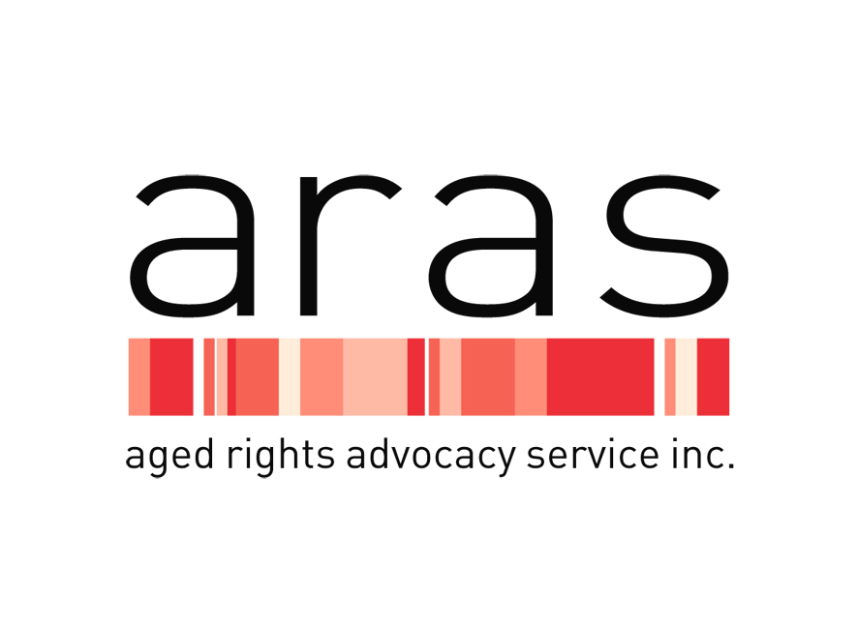

THE AGED RIGHTS ADVOCACY SERVICE INC. (ARAS)

POSITION DESCRIPTION

Applicants are requested to respond to the person specification in their application.
Please send written applications to Carolanne Barkla, Chief Executive ARAS, 16 Hutt St Adelaide 5000. Phone Inquiries to be directed to Louise Herft: 08 8232 5377.

ARAS has a website at www.sa.agedrights.asn.au

Role Title Advocate

Employment Status Full Time/Part Time (Several Positions)

Location Adelaide

Classification Level Social Community Home Care and Disability Services Award 2010 Level 4 to Level 6 plus additional benefits of ARAS Enterprise Agreement – Contract Position until June 2018 with possible extension subject to ongoing funding. There is also first option of paying for private use of an ARAS work car.

Purpose of Role

The purpose of the Advocate position is to provide information, education, support and representation to ARAS clients and to ensure that clients are sufficiently informed to empower them to make their own choices and have their rights and interests respected.

The Advocate reports to and works closely with the relevant Program Manager and maintains a collaborative and productive working relationship with all other staff within ARAS.

The Advocate is responsible for ensuring that all information and services provided are consistent with the purpose, vision, and values of ARAS and comply with relevant legislation, quality standards, contemporary research and practice. ARAS aspires to reflective practice in all aspects of work, continuous quality improvement and the highest possible standards of service provision.

ARAS advocates are able to support older people or their representatives who are:
- seeking or receiving Commonwealth subsidised community based aged care services and residential aged care;
- Who are living in a Retirement Village in South Australia;
- Who are at risk or, or are being abused by family and friends.

Advocacy and Support

- Delivery of high quality advocacy through information, education, support and representation including at SACAT.
- Intake duties and provision of appropriate referrals and information.
- Networking activities and building partnerships with other organisations to promote ARAS services.
- Provision of advocacy at an individual or systemic level to achieve satisfactory resolution of issues for clients or their representatives.
- Support clients to ensure they understand their rights, responsibilities and entitlements and provide support when they wish to voice their concerns, ask questions or make a complaint about their services.
- Utilize ARAS tools, procedures and presentation methods to present and promote ARAS services.
- Maintain high standard of recording and consultation.
- Participate in and contribute to Continuous Quality Improvement systems and any relevant quality review or accreditation.
- Represent and promote ARAS at workshops, forums, public engagements and networking meetings.
- Identify service needs and gaps from ARAS work and provide feedback to Program Managers and Chief Executive.
- Maintain up to date knowledge and understanding of the relevant legislations, guidelines, policies and procedures.
- Develop and meet targets within the relevant program key performance indicators.
- Contact and liaise with existing older people support groups.
- Raise community awareness of identified issues.
- Develop strategic partnerships with special needs groups such as older people with a disability, Aboriginal, LGBTI, CALD, RRR communities as well as Veterans, Care Leavers, older people who are at risk of or who are experiencing elder abuse, homelessness or financially disadvantaged.

Teamwork and Communication

- Attend and actively participate in case discussions, team meetings and project work.
- Demonstrate the ability to work positively and communicate effectively within a team environment as well as autonomously to achieve service delivery excellence.
- Maintain and initiate regular and professional communication with work colleagues and management.
- Develop and maintain cooperative and harmonious relationships and work in collaboration with others to prevent and/or resolve difficulties.

Continuous Quality Improvement

- Ensure that all statutory requirements are being met or exceeded including but not limited to funding agreements, Commonwealth and State legislation and related regulations and guidelines.
• Promote and support reflective practice in all ARAS staff, and demonstrate commitment to continuous quality improvement.
- Identify opportunities and options to promote and support high quality service provision and the best outcomes for clients, their families and staff.
- Support action research projects relating to the provision of high quality services for clients and their families.
- Participate and contribute in Workplace, Health and Safety activities to ensure a safe work environment for clients, staff, visitors and the community.
- Identify continuous improvements for all policies and procedures that support the inclusion and participation of clients.

Administration and Documentation

  - High level knowledge / usage of Microsoft Office and database programs to perform the duties.
  - Plan and manage time effectively to complete tasks and meet deadlines.
  - Complete written communications with clients and external services as required.
  - Collect and record data for systemic issues and project work.

Personal and Professional Development

- Continue to develop professionally and personally to meet the changing needs of the position and the organisation.
- Participate in the organisation’s performance management process.
- Attend training as identified through the performance management process, or as identified by management.
- Maintain up to date knowledge of Workplace, Health and Safety, anti-discrimination and equal employment opportunity and other relevant legislation.
- Demonstrate knowledge of the organisation’s policies and procedures and a commitment to keep updated on emerging changes.

Behaviours

- Demonstrate empathy and compassion towards ARAS client group.
- Demonstrate commitment to ARAS and maintain a strong work ethic.
- Demonstrate integrity and trust towards the organisation and its client group.
- Operate autonomously whilst maintaining accountability and working within organisational frameworks.
- Demonstrate an openness to learn from others, take on constructive feedback and provide solutions.
- Demonstrate a high level of judgment when faced with complex situations.
- Demonstrate a willingness to undertake reflective practice for self-development.

Special conditions

- Current drivers licence essential.
- Some out of hours work and travel is required.
- A Police Certificate that is dated not more than 3 years before the day on which the person first becomes a staff member.

Work Health & Safety

In your own interests and as a legal obligation, you have a responsibility to take reasonable care
- To protect your own health and safety at work.
- To avoid adversely affecting the health and safety of any other person through any act or omission at work
- To obey any reasonable instruction that you may be given in relation to health or safety at work.
- To ensure that you are not, by the consumption of alcohol or a drug, in such a state as to endanger your own safety at work or the safety of any other person at work.
- To use any equipment provided for health and safety purposes
- To promptly report all accidents to the WH&S supervisor.

Key Selection Criteria

- Experience in working with and or advocating for people with a disability, older people, disadvantaged, vulnerable groups and operating within a social justice framework.
- A tertiary qualification in human services, law, social work, behavioural science and/or community services or an equivalent combination of relevant experience, education and/or training.
- Demonstrated ability to understand and apply legislation particularly Aged Care Act 1997 and related Principles and Retirement Villages Act 1987 and related regulations, policies and procedures, including the ability to identify issues and problem solve.
- Excellent written, verbal communication and presentation skills.
- High level computer skills – Microsoft Office or equivalent.
- Commitment to continuous quality improvement and to maintaining quality outputs.

August 2017

