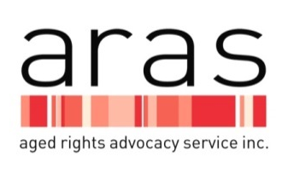
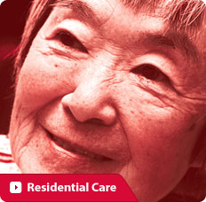

Risk Factors and the Effect of Abuse on the Older Person

Awareness of the risk factors that can contribute to the abuse of older people may assist individuals to consider safeguards to maintain control over their lives. The risk factors may involve one or more of the following:

Family conflict/dynamics - This includes a history of
- family violence
- conflict between siblings
- changing dynamics as the older person becomes frail
- a shift in the role of the older person within the family.
Dependency - Can involve either the older person or the alleged abuser, or be mutual. These dependencies can be physical, psychological, emotional or financial, for example, the older person may have
- a diagnosis of dementia or cognitive impairment with greater reliance on others for making decisions about their care and financial affairs.
- rely on the alleged abuser for transport or social contact; the alleged abuser may rely on the older person for accommodation, money.
- be dependent physically or emotionally on the alleged abuser and feel very distressed that their son/daughter is mistreating them.
Isolation - This can include
- geographical isolation and/or
- being restricted socially due to physical disability or frailty.
Older people who maintain a connection with their community, appear to have a decreased risk of being abused. In rural or remote areas, local support and resources may be limited and people may be reluctant to discuss personal issues with service providers living in the same community.

Alcohol and substance abuse - This may be a pattern of dependency for either the older person or the alleged abuser and can influence the ability to make decisions, protect themselves or stop abusive behaviour. The older person may
- need to be supervised when taking medications so that incorrect dosage or the wrong medication is not consumed; the alleged abuser; dependency on drugs and/or alcohol may cause inappropriate or violent behaviour.

Effects of an Abusive Situation on the Older Person

Older people may be reluctant to admit that they are experiencing mistreatment of any kind, particularly from a close family member. They can experience shame and disbelief and keep hoping that the abuse will stop.

Older people may be reluctant to confide in anyone due to fear of retribution not only from the alleged abuser but also from other family members.

Older people may want to protect the alleged abuser from getting into trouble. This may occur when the abuser has a mental illness or other disability.

It is important for older people to know that abuse is NOT OK and that they should talk to someone about it. The Abuse Prevention Program is a confidential service and will ensure that your wishes are listened to and respected. What finally prompts an older person to approach the Abuse Prevention Program, is the realisation that if they do not seek help, their circumstances may not change. If necessary, ARAS advocates can travel to regional areas to assist a consumer.

ARAS promotes the following:

Older people have rights
Abuse of these rights is NOT OK
Help is available
Good planning can safeguard your rights.

Abuse Prevention Program provides
- Information sessions to community groups
- Informative and interactive education sessions to service providers, TAFE/Universities/medical students and health and allied health professionals in hospital settings
- Assist service providers with policies to ensure the rights of older people are upheld.

Please contact ARAS:
Telephone: 8232 5377 or 1800 700 600 (free-call for country callers)
TTY: 13 36 77 or SSR: 1300 555 727
Translating and Interpreting Service: 13 14 50
Email: aras@agedrights.asn.au
Website: www.sa.agedrights.asn.au

This fact sheet provides general information only and is not intended to substitute for legal advice. Whilst care has been taken to ensure the accuracy of the material, no responsibility can be taken for any errors or omissions.
ARAS is supported by financial assistance from the Australian Government and the Office for the Ageing, SA Health.

