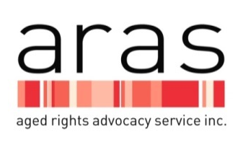
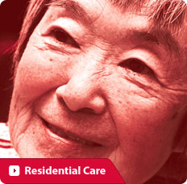

Abuse Prevention Program

Older people who are living in the community and who are experiencing, or are at risk of abuse from those with whom they are in a relationship of trust such as, family or friends will be assisted by the Abuse Prevention Program. The aim is to build on their individuals’ strength and resilience to improve their health, wellbeing and safety through the provision of advocacy support. Abuse may include one or more of the following forms: financial, psychological/emotional, physical, sexual, social and / or neglect.

Who does the Abuse Prevention Program assist?
- Older people who are at risk of, or experiencing abuse from those with whom they are in a relationship of trust, such as family or friends. The ARAS Residential Aged Care Program supports residents of aged care facilities who are experiencing abuse.
- An older person’s representative, who is acting in the best interest of the older person or who is a substitute decision-maker or legally appointed.
- Service providers who will provide information and support to the older person to ensure their rights are upheld.
How the older person will be assisted
With the older person taking the lead, we will work along- side them;
- Providing information about your rights
- Providing options to help with your situation of abuse by someone you should be able to trust.
- Advocating to service providers on your behalf
- Support to implement strategies to reduce and/or stop the abuse
Abuse Prevention Program also provides
- Information sessions to community groups
- Informative and interactive education sessions to service providers, TAFE/Universities/medical students and health and allied health professionals in hospital settings
- Assist service providers with policies to ensure the rights of older people are upheld.

You have rights – do you know what they are?
The South Australian Charter of the Rights and Freedoms of Older People has been endorsed by the Strategy to Safeguard the Rights of Older South Australians and is based on the United Nations Principles for Older Persons (1991) and includes the following:
Dignity and  Self-determination | - Older people have the right to be treated with dignity and humanity and to be free to exercise personal self-determination.  - Older people have the right to freedom of movement and to choose their place of residence. These rights shall only be restricted in accordance with law, where such restriction is necessary to protect public health, public order and the rights and freedoms of others.
Liberty and security of the person | - Older people have the right to be free from torture or other forms of cruel, inhuman or degrading treatment.  - Older people have the right to liberty and security and to be free from exploitation and physical, social, psychological, financial and sexual abuse. No person shall be deprived of their liberty except in accordance with procedures established by law.
Equality and non-discrimination | - Older people have the right to exercise their rights free from all forms of discrimination, whether on the basis of age, sex, colour, sexual, orientation, religion, political opinion, educational qualification, national origin or ethnicity.  - Older people have the right to recognition before the law and to be treated equally before the law.
Standards of living and care | - Older people have the right to food to nurture them nutritionally and emotionally, adequate clothing and shelter, adequate means and resources, to enjoy the highest attainable standards of physical and mental health and the right to a dignified death.
Other Rights and Freedoms of Older People are Privacy and family; Social and economic participation; Freedom of thought, conscience, spirituality, religion and expression.

Please contact ARAS:
Telephone: 8232 5377 or 1800 700 600 (free-call for country callers)
TTY: 13 36 77 or SSR: 1300 555 727
Translating and Interpreting Service: 13 14 50
Email: aras@agedrights.asn.au
Website: www.sa.agedrights.asn.au

This fact sheet provides general information only and is not intended to substitute for legal advice. Whilst care has been taken to ensure the accuracy of the material, no responsibility can be taken for any errors or omissions.
ARAS is supported by financial assistance from the Australian Government and the Office for the Ageing, SA Health.

